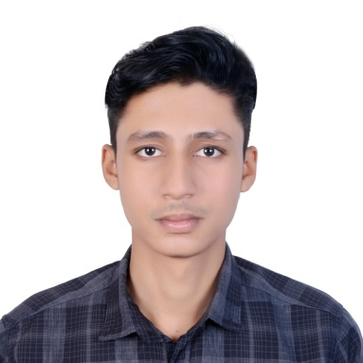***RESUME OF***

***Md. Parvez Hasan***

***Mobile: 01709 692379***

**Present Address:**

139, Road # 5,

Block-B, Bashudhara R/A

Dhaka-1229.

**Career Objective:**

I would like to work in such workspace where sincerity is highly appreciated and in innovate working atmosphere is providing accordingly. Looking for a challenging position to build up my successfully career.

**Academic Qualification:**

**Name of Examination : Secondary School Certificate (S.S.C)**

Institute : Ranjitpur High School

Group : Science

Passing Year : 2018

Result : 3.67out of 5.00

Board : Jessore Board

**Name of Examination : Higher Secondary School Certificate (H.S.C)**

Institute : Islamia College, Kushtia.

Group : Humanities

Passing Year : 2020

Result : 4.00 out of 5.00

Board : Jessore Board

**Bachelor of Business Administration (BBA)**

Institute : Independent University Bangladesh

Major : International Business

Passing Year : Running

**Communication Skills:**

* Consideration Fluency in Bengali and good in English.
* Have ability to do team/individual presentations on various projects, cases and reports in distinctive courses.

**Computer Skills:**

Microsoft Word, Microsoft Excel & Internet Browsing etc.

**Personal Information:**

Father's Name : Md. Abdus Salam

Mother's Name : Rokshana Khatun

Permanent Address : Vill : Ranjitpur, P.O. : Karimpur

P.S. Kustia Sadar, Dist. Kushtia

Date of Birth : 29th November 2001

Nationality : Bangladeshi (By Birth)

Religion : Islam

Marital Status : Unmarried

Height : 5'-9"

Blood Group : AB+

**Declaration:**

I declare that all information mentioned above is true to the best of my knowledge. If necessary, al the authentic papers would be submitted.

**Md. Parvez Hasan**

Date: